Diffuse Light

📘 Definition
# Source: AI Source: Provided by: [Data Path: Persons Table -> ID Column: 1, Name_En Column: Motasem Essam] -> From: [ChatGPT] on [5/2/2026]
Diffuse light is light that, after hitting a surface, spreads out in many directions instead of reflecting in a single direction. It makes objects look soft, matte, and evenly lit without strong shine.

🌫️ How diffuse light works
# Source: AI Source: Provided by: [Data Path: Persons Table -> ID Column: 1, Name_En Column: Motasem Essam] -> From: [ChatGPT] on [5/2/2026]
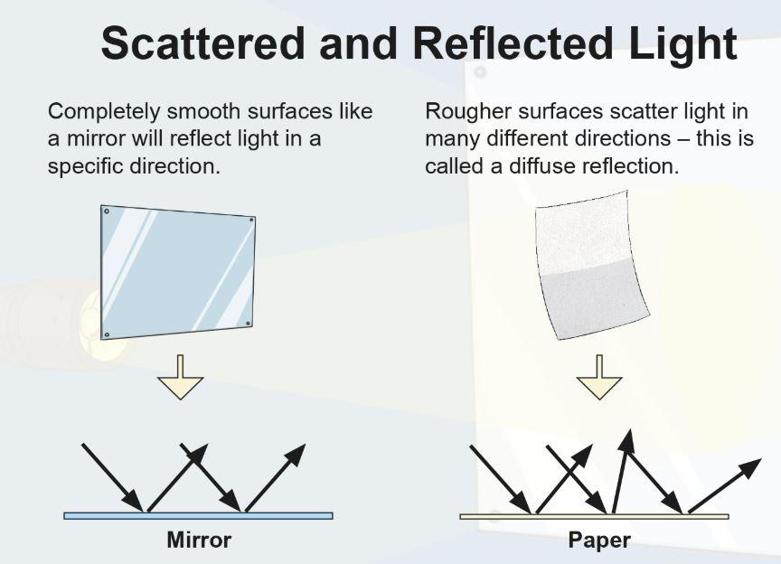
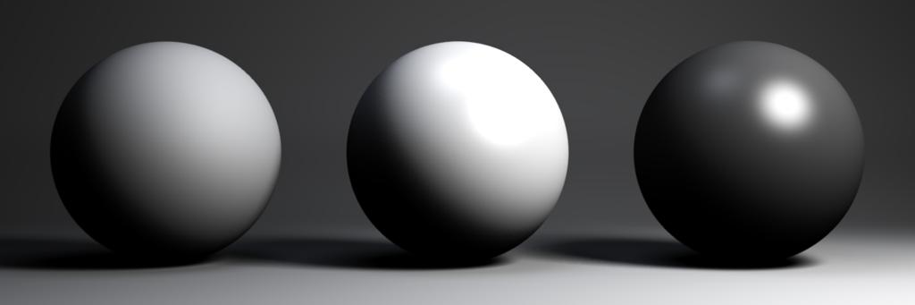
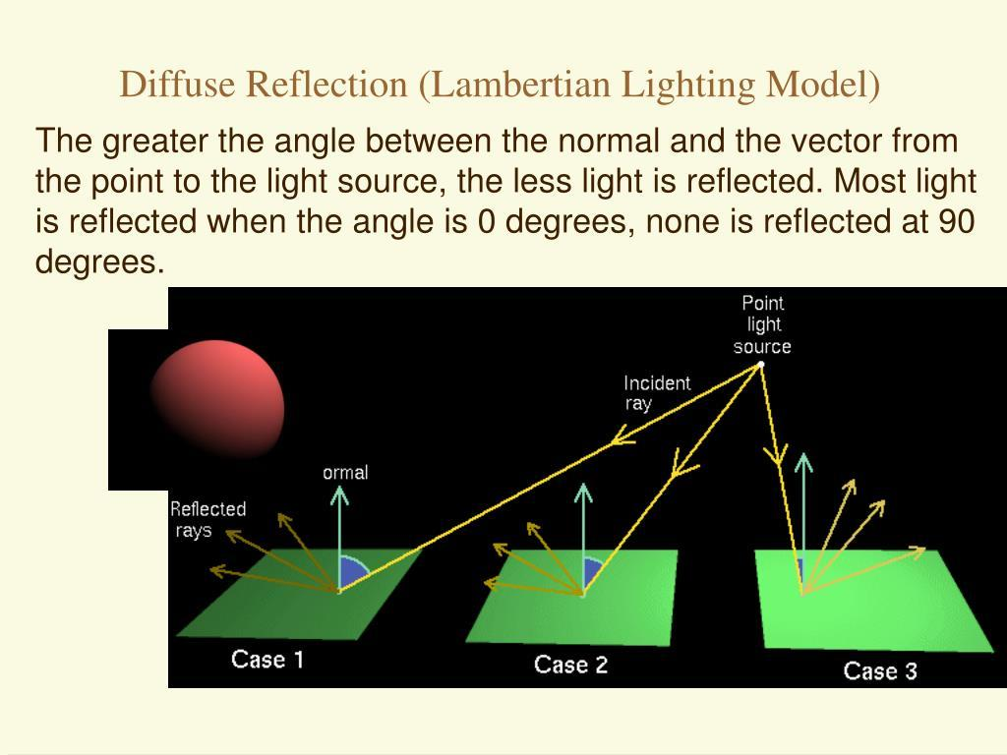
- Light hits a rough surface
- The surface scatters light in all directions
- No clear reflection is formed
- The object appears uniformly lit

🧠 Simple example
# Source: AI Source: Provided by: [Data Path: Persons Table -> ID Column: 1, Name_En Column: Motasem Essam] -> From: [ChatGPT] on [5/2/2026]
Think of:
- 📄 A sheet of paper → evenly lit, no shine
- 🧱 A wall → looks bright but not reflective
- 👕 A cotton shirt → soft, non-glossy appearance

🎮 Diffuse light in computer graphics
# Source: AI Source: Provided by: [Data Path: Persons Table -> ID Column: 1, Name_En Column: Motasem Essam] -> From: [ChatGPT] on [5/2/2026]
Diffuse light is used to:
- Create natural-looking materials (skin, wood, fabric)
- Add basic shading and depth
- Simulate how light spreads in real life
- Form the base of lighting models like Lambert and Phong

⚙️ Key features
# Source: AI Source: Provided by: [Data Path: Persons Table -> ID Column: 1, Name_En Column: Motasem Essam] -> From: [ChatGPT] on [5/2/2026]
- 🌫️ Light is scattered in many directions
- 🚫 No shiny highlights
- 🎯 Depends on angle of incoming light
- 🧩 Makes objects look matte and realistic

🚀 In short:
# Source: AI Source: Provided by: [Data Path: Persons Table -> ID Column: 1, Name_En Column: Motasem Essam] -> From: [ChatGPT] on [5/2/2026]
Diffuse Light = light that spreads evenly in all directions after hitting a rough surface, creating a soft and non-shiny look.

